
INSTALLING V-PULLEY ON THE DRIVE MANDREL

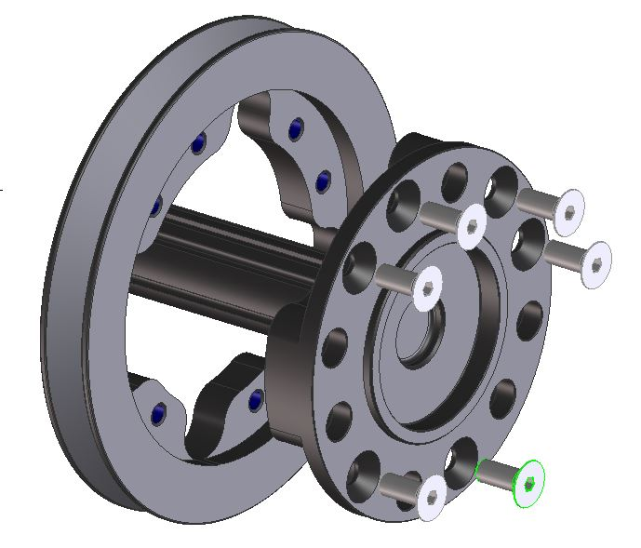

Use removable thread locker on all screws.

